Highcliffe School Student Bulletin

Monday 25th – Friday 29th June 2007: Week A

Thought For The Week:
Not everything that can be counted counts, and not everything that counts can be counted.
Albert Einstein

4:1 Days return


Year 10 maths revision for Module 3 exam is on Tuesday 26th June: 3.20-4.20pm in Room Ma3

ICT: A reminder to all Year 10’s that this year’s project work for ICT needs to be completed before Work Experience.
New projects start in year 11.

Year 10 Catering Exam: The following students will be taking their Year 10 Catering Exam on the following days:

Monday 2nd July 2007 | Tuesday 3rd July 2007 | Thursday 5th July
Chris Banks | Gemma Beale | Jessica Binns
Hollie Harvell | Lydia Cunningham | Bethany Jessop
Alex Inman | Oli Hillyer-Riley | Zoë Lumb
Gemma Keffen | Emily Kerr | Dani Seton
Rachael Pennell | Michael Stansbie | Aimee Chester
Francesca Wood | Aimee Hamerston-Budgen | Amy Edwards
Lauren Blatch | Charlotte Mortimer | Sam Gibbins
Jemma Blundell | Robynn Phillips-Major | Bryony Harris
Rebecca Cavan | Rachael Smith | Lucy Harrold
Jade Clarke | Laurence Sugden | Stacy Holland
Hannah Currie | Layla Tannetta | Sarah Money
Scott Chandler | Chris Tye | Sarah Money
Sarah Money | Danielle Corp | Sarah Money


MUSIC NOTICES -
The summer concert for 2 nights only 5th and 6th July: Tickets on Sale Now!

Rehearsals:

Guitar Club - Monday 3.30pm - 4.30pm

Harmonious Funk Jazz band - Tuesday 3:30pm – 5.00pm

Shout - Wednesday 3:30pm - 4:30pm (Years 7 - 9)

Vocalis - Thursday 3:30pm - 4:30pm (Years 10 - 13)

PE NOTICES
Year 8 tennis v BSB - Team A - lost, Team B - won
Year 8 tennis v Dorchester Middle - lost

Year 8 tennis v Wey Valley - won
Year 10 tennis v Sherbourne - lost
Year 10 tennis v QE - lost
Year 9 rounders tournament - 4th overall
Year 10 mixed rounders v Ferndown - won
Year 10 mixed rounders v Poole High - won

SUPER FACTS:

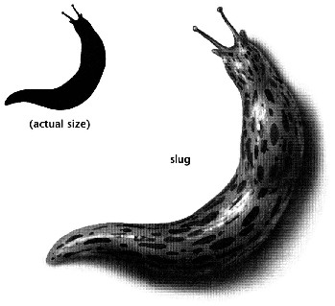
A lightning bolt generates temperatures five times hotter than those found at the sun's surface!

Forest fires move faster uphill than downhill!

Slugs have 4 noses!

The fear of vegetables is called Lachanophobia!

P.E. FIXTURES/PRACTICES

25th June – 29th June 2007

 | LUNCHTIME | AFTER SCHOOL
Monday 25th |  | Years 7 & 8 rounders v Wentworth (A)
Tuesday 26th | Year 10 cricket | Year 9 cricket v BSB (A)  Year 8 cricket v BSB (H)  Years 9 & 10 tennis v Grange (H)
Wednesday 27th | Year 7 cricket | Athletics club  Year 8 rounders tournament @ Grange (2pm start)  Year 9 rounders v Wentworth (H)  Year 7 cricket v Beaminster (A)
Thursday 28th | Year 8 cricket | Year 10 rounders v Corfe Hills & BSG (@ Corfe Hills)  Year 10 cricket v BSB (H)
Friday 29th | SPORTS DAY

